

**South Gas Regional Initiative**

**Roadmap for Congestion Management Procedures**

April 2013

**INDEX**

1 Background 3

2 Areas of work 4

2.1 Application 4

2.2 Calendar for implementation in the South Region 4

3 Detailed implementations Rules for CMP in the South Region 7

3.1 Capacity increase through oversubscription and buy-back 7

3.2 Firm day-ahead use-it-or-lose-it mechanism. 9

3.3 Surrender of contracted capacity. 9

3.4 Long-term use-it-or-lose-it mechanism 13

1. Background

On 24 August 2012 the Commission issued a Decision on amending Annex I to Regulation (EC) No 715/2009 of the European Parliament and of the Council on conditions for access to the natural gas transmission networks.

This Decision introduced new rules to be applied in the event of contractual congestion and is aimed at resolving those events by bringing unused capacity back to the market to be reallocated in the course of the regular allocation process.

The congestion management procedures (CMPs) shall apply at interconnection points between adjacent entry-exit systems, irrespective of whether they are physical or virtual, between two or more Member States or within the same Member State in so far as the points are subject to booking procedures by users.

Besides, in order to ensure that CMPs are applied in the most effective way and with a view to maximising available capacities in all adjacent entry-exit systems, it is of great importance that NRAs and TSOs from different Member States and within Member States closely cooperate amongst themselves and with each other. In particular national regulatory authorities and transmission system operators should have regard to best practices and endeavour to harmonise processes for the implementation of these Guidelines.

In relation to this, during the 21st Implementation Group of the South Gas Regional Initiative, TSOs were asked to develop a roadmap for the implementation of the congestion management procedures at IPs within the region. Thus, the purpose of this document is to detail among other aspects, the working arrangements, time schedule, roles and responsibilities and geographical scope.

The following Draft CMP Roadmap is a proposal and must not be seen as a formal engagement from TSOs until further precisions are given to the different mechanisms

1. Areas of work
   1. Application

According to recital (3) of the Annex I to Regulation 715/2009 *the congestion -management procedures should apply in the event of contractual congestion and are aimed at resolving those events by bringing unused capacity back to the market to be reallocated in the course of the regular allocation processes.*

Moreover, Article 2.2 of the Annex is titled: “Congestion management procedures in the event of contractual congestion”, which means that the mechanisms described should only be applied in case contractual congestion is identified at an IP.

As regards physical congestion, recital 4 of the Annex says “*Where an interconnection point is frequently subject to the occurrence of physical congestion, congestion management procedures may often be of no avail. In those cases a solution should be examined from a network planning and investment point of view.”*

Within this context, TSOs firmly believe that the oversubscription and buy-back procedure requires a particular evaluation of the congestion situation due to the risks and rewards associated for TSOs and this mechanism shall not be put in place at an IP subject to physical congestion.

The decision to apply or not must be subject to the result of an assessment made at each IP to evaluate the congestion situation as well as the market needs.

TSOs will carry out this assessment on a yearly basis at each IP to identify whether the IP is contractually congested and whether there is physical congestion or not. Based on this assessment, TSOs will submit NRAs a report and if an IP if physically congested, then TSOs will propose not to apply oversubscription & buy-back.

In the event that the result of an assessment indicates that there is a need to put in place the CMP mechanisms at a certain IP, a proposal to implement these mechanisms is detailed hereunder.

* 1. Calendar for implementation in the South Region

The revised Annex I to Regulation (EC) 715/2009, dated the 24th August 2012, specifies the deadlines for implementation of congestion management procedures in all Member States. Some of these procedures are not likely to be effective in each IP within the region until after the implementation deadline of such CMP measures, since CAM NC provisions shall only fully enter into force 27 months after the date of its publication, which lies beyond the before mentioned implementation dates, except for Firm Day-ahead UIOLI procedure. Therefore, NRAs and TSOs agree on the definition of an interim period for some of the CMP measures, where actual on-going rules and procedures shall prevail.

Thus the proposed implementation calendar for CMP measures is as follows:

Figure 1 : CMP implementation roadmap for the period 2012/2013

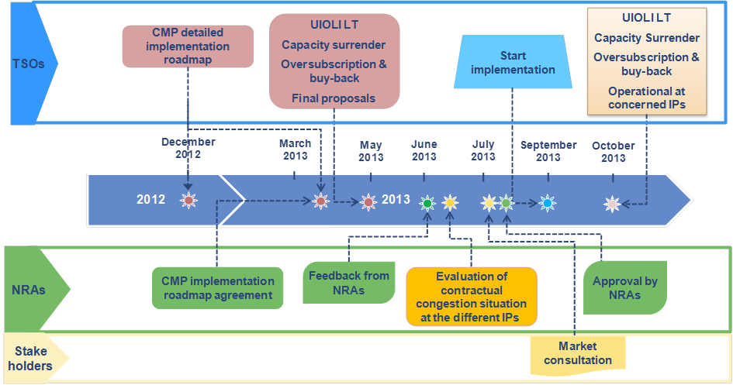

Figure 2 : CMP implementation roadmap for the period 2015/2016

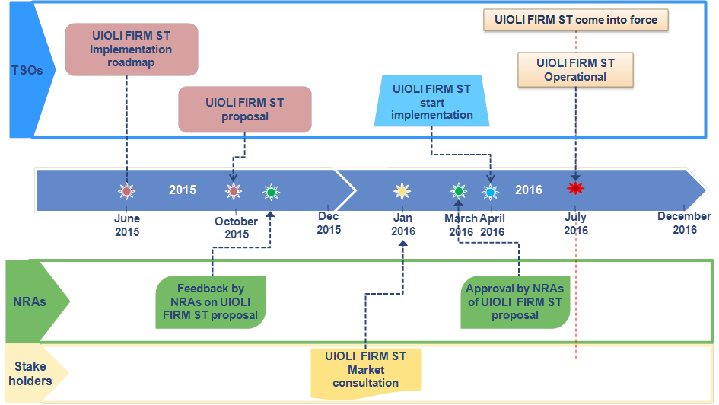

Table 1 : S-GRI detailed work plan

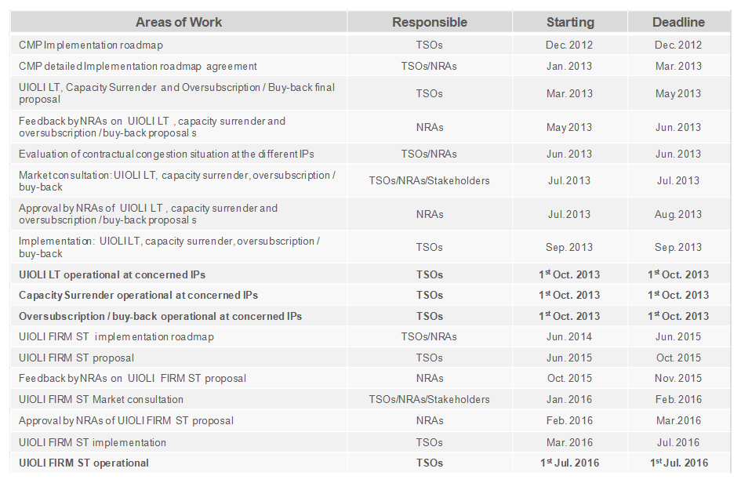

1. Detailed implementations Rules for CMP in the South Region

Given the differences of implementation stages and rules of CMP that are present across the IPs within the region, the rules proposed in this chapter for the four different CMP mechanisms have as an objective to guarantee a smooth and firm transition from the current status at each border and the final foreseen measures to be implemented according to Annex I to the Gas Regulation in the South Region, taking into account the likelihood of congestions and thus the applicability of each measure in the upcoming years.

The proposed measures also take into consideration that full implementation of CMP mechanisms in all borders request for significant investments in IT solutions, which may not be recommended to a certain extent given the current situation of capacity use at the different IPs in the region.

* 1. Capacity increase through oversubscription and buy-back

According to Annex I to Regulation 715/2009, TSOs shall propose and implement an incentive-based oversubscription and buy-back scheme in order to offer additional capacity on a firm basis based on statistic studies. The application of this mechanism will result in potential additional costs for the TSOs in relation to the additional capacity proposed and the need to buy-back capacity in case of physical congestion and shall be subject to a cost-benefit analysis performed by the NRA. Due to the limitations of the statistical studies and to control these risks, additional capacity offered for yearly products shall be limited to Y+1. This mechanism necessitates a close coordination amongst adjacent TSOs and NRAs to propose additional capacities and to define a rule on the buy-back procedure.

In case a physical congestion is likely to occur for a specific day at an IP, adjacent TSOs must evaluate the risk of threat to system integrity and shall first verify whether more cost-efficient alternative technical and commercial measures can be applied before launching a buy-back scheme, including the interruption of interruptible capacity.

Several market-based buy-back procedures could be used such as market intervention through a specific IT tool and/or an option mechanism. The development of a buy-back market-based approach will require strong coordination at European level to develop an electronic buy-back platform in the most harmonised and cost efficient way.

All potentially envisaged buy-back mechanisms will imply to define a default rule to guarantee the effectiveness of the oversubscription and to mitigate the TSOs’ risks.

The implementation of the oversubscription and buy-back mechanism will also incur costs and risks for TSOs which have to be incentivised and recovered in a timely manner via network tariffs, congestion revenues or appropriate mechanisms as determined by National Regulatory Authorities.

In relation to its implementation, several issues need to be previously addressed in more details:

* The choice for alternative buy-back procedures, such as market intervention through a specific IT tool or an option mechanism
* Transparency issues regarding the implementation of such mechanisms;
* The possible development of an electronic buy-back platform at European level to respond to a market-based approach for the buy-back mechanism.
* Common criteria to calculate the additional firm capacity to be offered coordinated with the definition of interruptible capacity.
* Evaluation of measures to be applied by TSOs before the buy-back scheme is launched.

Finally, it should be noted that, in order to be applicable, the launch of this buyback procedure would imply a prohibition on shippers being able to re-nominate upwards on the point in question.

We therefore propose that, to start with, the buyback mechanism should be based on the application of the following simple rule. When shippers’ nominations on a given point exceed the performances of the transmission system on a given day, the transmission operator would buy back firm capacity at a regulated price from each shipper holding firm capacity on the point in question, in proportion to the firm capacity it holds and after suspending interruptible capacity at the point concerned. The practical requirements of the system are currently being studied, since they depend on how often buyback is used.

Next, from 2014-2015, we could consider proposing a market-based buyback mechanism operating on the above-mentioned electronic platform and/or via the capacity buyback option.

In our view, this proposal for gradual implementation is both more reasonable and more efficient. It will allow us:

* to adjust more effectively the exact amount of oversubscription that could subsequently be proposed, based on feedback from the first period;
* to introduce a mechanism that is harmonised with the adjacent countries;
* to share the cost of implementation with other transmission system operators.
  1. Firm day-ahead use-it-or-lose-it mechanism.

Considering that this procedure shall only apply as of 1 July 2016, this document will not cover this mechanism. A specific roadmap for the implementation of DA UIOLI shall be subject to TSOs proposal in due time. The studies will begin in 2014.

* 1. Surrender of contracted capacity.

Transmission system operators shall accept any surrender of firm capacity which is contracted by the network user at an IP, with the exception of capacity products with a duration of a day and shorter.

* + 1. Surrender products and possible TSO re-allocation

In order to offer surrendered capacity in the regular allocation process, TSOs shall accept surrender of any amount of capacity from any booked standard capacity product of a duration between one and twelve months and with a starting date not beyond the 30th September of the following year.

Article 8 of CAM NC provides for a share of the technical capacity to be systematically set aside for short-term subscriptions (with a maturity lower than one year) and on the other hand, according to the Annex CMP, surrendered capacity shall be considered to be reallocated only after all the available capacity has been allocated making it impossible to offer surrendered capacity as yearly standard products. Therefore, given the provisions of the CAM network code and the Annexe CMP, yearly capacity products might only be reoffered to the market by TSOs as quarterly and monthly standard capacity products following the harmonised auction calendar.

Any capacity booked at rolling monthly capacity auctions might not be surrender as there is no additional auction window to reoffer monthly products again.

Figure 3 : Capacity products related to the surrender of booked capacity procedure

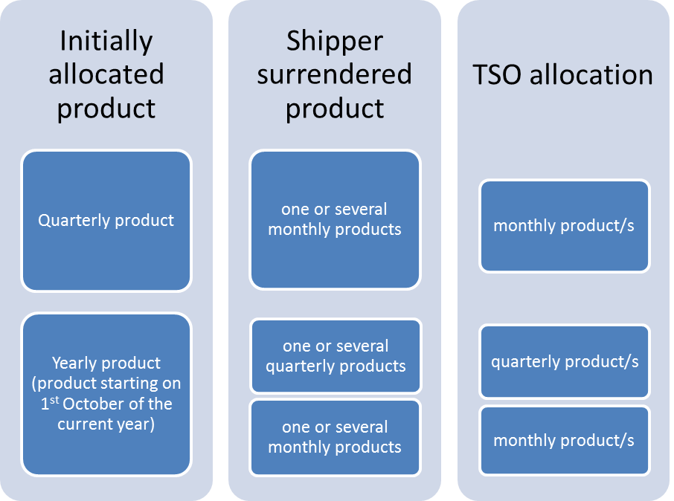

* + 1. Surrender calendar

To be reoffered by TSOs, capacity products shall be surrendered by shippers some time before the commercialization period foreseen in the auctions calendar in order to allow TSOs the inclusion of the surrendered capacity into the products offer. For Quarterly products the deadline for surrendering is set on the first working day of May, whilst for Monthly products this limit is set on the first working day of month M-1 to surrender Monthly product M.

Surrendered capacity shall not be offered by shippers at the secondary market until they received the notification from the TSO regarding the re-allocation or not of the capacity at the respective auction.

**Figure 3: Monthly products surrender of contracted capacity calendar**



**Figure 3: Quarterly products surrender of contracted capacity calendar**



* + 1. Surrender examples
* Shipper A booked 10 GWh/d of the Yearly product Y. Shipper A might surrender up to 10 GWh/d of capacity for any month or quarter within the respective yearly product. If the capacity surrender takes place before the first working day of May, any suitable surrendered capacity product (a quarter or three months corresponding to a quarter) shall be offered by the TSO at the annual quarterly capacity auction that takes place on the first Monday of June of year Y. If capacity is surrendered after the annual quarterly auction was held, TSO shall offer the surrendered capacity at the rolling monthly auctions.
* Shipper B booked 8 GWh/d of the Yearly product Y and 5 GWh/d of the Quarterly product Q2. Shipper B might surrender up to 8 GWh/d of capacity for any month or quarter of year Y and up to 5 GWh/d of capacity for April, May or June of year Y+1. In this case, as the quarterly capacity auction has already taken place, any surrendered capacity shall be offered by the TSO at the rolling monthly capacity auctions.
  + 1. Surrender mechanism provisions

When surrendering capacity shippers must inform TSOs the respective auction where this capacity was booked.

Shippers may surrender both bundled and unbundled capacity, which in the latter case shall always be combined, if possible, with available unbundled capacity on the other side of the border, before it is reallocated.

Surrendered capacity shall be considered to be reallocated only after all the available bundled capacity has been allocated, but before the allocation of any capacity released through an UIOLI procedure. Surrendered bundled capacity shall not be reoffered to the market if more than 10 % of the total technical capacity at an IP remains unsold as unbundled capacity.

Surrendered capacity products shall be definitively surrendered until the TSOs communicate the results of the respective auction. If unsold, surrendered capacity is given back to the original capacity holder after the auction.

The network user shall retain its rights and obligations under the capacity contract until the capacity is reallocated by the transmission system operator and to the extent the capacity is not reallocated by the transmission system operator.

In case that more than one shipper surrenders capacity, the allocation priority will be the time stamp of surrendering.

The implementation of the capacity surrender mechanism will imply additional costs for TSOs for processing these capacities (surrender requests reception, capacity origin identification, allocation priority management, invoicing of price difference, publications, etc) with significant IT developments required.

In order to cover these costs, a fee is to be introduced to reflect the cost of service and to avoid a loss of revenue for the TSO. It also envisages incentivizing an efficient booking of capacity by network users. Thus, the shipper holding the original capacity would be billed for the surrender service at a level equal to the maximum of the two following amounts:

* 1% of the initial selling price,
* the difference between the initial price of the capacity and the reallocation price (if positive)

This price would prevent surrender becoming a mechanism for re-buying capacity at a better price. Indeed, offering shippers a free service would encourage them to use the release mechanism to play again the auction process, for example in the case of congestion due to flow conditions disappearing.

* 1. Long-term use-it-or-lose-it mechanism

The long-term use-it-or-lose-it mechanism (LT UIOLI) is under application in France since 2007 and in Spain since 2003. No LT UIOLI mechanism is in force in Portugal, since no long-term capacity products are available to the market.

However, TSOs acknowledge that harmonisation within the region is needed to adapt the rules under application to the CAM NC.

Thus, TSOs propose to start the analysis of the capacity utilisation by 2015, once the CAM NC is already implemented within the region.

For the interim period, before the start of CAM auctions, TSOs will continue with current arrangements.

At IPs where CAM auctions are in place, the application of the LT UIOLI mechanism will be triggered if demand exceeds offer at the yearly capacity auctions by IP/VIP.

* + 1. Application of the procedure

According to article 1 of the LT UIOLI procedure, *NRAs shall require TSOs to partially or fully withdraw systematically underutilised contracted capacity on an interconnection point by a network user where that user has not sold or offered under reasonable conditions its unused capacity and where other network users request firm capacity.*

Thus, the ultimate responsibility to withdraw the capacity lies in the NRAs. For this purpose, TSOs will provide NRAs with all the data and information necessary for the application of the LT UIOLI, which shall include at least: the utilisation rate of capacity contracts, a proposition for the potential capacity to be withdrawn to each network user, network users justification for not using the capacity and a proposition for the amount of capacity to be reoffered.

Once NRAs have received all the information, NRAs shall communicate TSOs the final capacities to be withdrawn to each envisaged network user’s contracts and reoffered on the following annual quarterly capacity auctions.

* + 1. When will be the LT UIOLI triggered

The LT UIOLI will be triggered, if two conditions are met:

1. the capacity demanded at the reserve price (P0) for the yearly standard capacity product Y[1] is higher than the capacity offered at the reserve price step (P0) or all the technical capacity reserved for long-term contracts is already contracted.
2. the total capacity allocated under long-term contracts shall be at least 80% of the technical capacity reserved for long-term contracts.

If the annual yearly capacity auction does not take place due to the lack of available capacity, then the LT UIOLI procedure will be automatically triggered. Under this circumstance the capacity to be released shall not be limited and all the systematically underutilised capacity will be reoffered to the market.

The total amount of capacity to be released will be limited to the demand exceeding the offer at the reserve price in the annual yearly capacity auction for year Y.

* + 1. Systematic underutilisation

According to Annex I to the Regulation, contracted capacity shall be considered to be systematically underutilised in particular if:

1. the network user uses less than on average 80% of its long-term contracted capacity both from 1 April Y-1 until 30 September Y-1 and from 1 October Y-1 until 31 March Y and for which no proper justification could be provided; or
2. the network user systematically nominates close to 100% of its contracted capacity and renominates downwards with view to circumventing the firm day-ahead UIOLI mechanism included in Regulation.

To calculate the rate of utilization of contracted capacity, it will be taken into account the last nomination/renomination sent by the network user to the TSOs.

In case of systematically underutilization of contracted capacity, the respective network user may lose part or the whole of its contracted capacity for the period from 1 October Y to 30 September Y+1, which will be subject to offer at the following quarterly capacity auction.

For each network user two different types of contracted capacity shall be subject to the LT UIOLI procedure:

* Contracted capacity before the implementation of the NC on CAM with a duration of one year or more.[2]
* Contracted capacity at the annual yearly capacity auctions after the implementation of the NC on CAM.

For the purpose of the LT UIOLI procedure both types of contracted capacity will be defined as Long-term Contracted Capacity.

Only capacity related to Long-term Contracted Capacity will be subject to the LT UIOLI analysis and will be released.

* + 1. Amount of capacity to be released

Long-term Contracted Capacity during the period from 1 April Y-1 until 31 March Y, divided in two semesters, will be analysed.

For each network user two different percentages of systematic underutilised capacity shall be calculated: one for summer period, from 1 April Y-1 until 30 September Y-1, and another one for winter period, from 1 October Y-1 until 31 March Y.

The percentage of systematic underutilised capacity for summer period will be defined as Summer Percentage, and percentage of systematic underutilised capacity for winter period will be defined as Winter Percentage.

The Summer Percentage shall be calculated as the average of:

* daily Long-term Used Capacity from 1 April Y-1 until 30 September Y-1

divided by

* daily Long-term Contracted Capacity from 1 April Y-1 to 30 September Y-1.

The Winter Percentage shall be calculated as the average of:

* daily Long-term Used Capacity from 1 October Y-1 until 31 March Y,

divided by

* daily Long-term Contracted Capacity from 1 October Y-1 until 31 March Y.

Withdrawal may result in the network user losing its Long-term Contracted Capacity for year Y, from 1 October Y to 30 September Y+1.

For each network user, the potential Long-term Contracted Capacity to be withdrawn during year Y will be independently calculated for summer period, 1 April Y+1 to 30 September Y+1, and for winter period, 1 October Y to 31 March Y+1.

The potential contracted capacity to be withdrawn in summer period will be calculated as:

(1 - Summer Percentage) * Long-term Contracted Capacity from 1 April Y+1 to 30 September Y+1

And, the potential capacity to be withdrawn in winter period will be calculated as:

(1 - Winter Percentage) * Long-term Contracted Capacity from 1 October Y to 31 March Y+1

Therefore, for each network user subject to the application of this procedure, different amounts of Long-term Contracted Capacity will be potentially withdrawn during summer period and winter period.

If a shipper has several Long-term Capacity Contracts from October Y to September Y+1, Long-term Contracted Capacity with the highest premium shall be first withdrawn.

If the total capacity to be withdrawn from network users is higher than the difference between the capacity demanded at the reserve price (P0) for the yearly standard capacity product Y (from 1 October year Y to 30 September year Y+1) and the capacity offered at the reserve price (P0) for the related period, then pro-rata should be applied.

* + 1. Reoffered of released capacity

The potential Long-term Contracted Capacity to be withdrawn will be again offered to the market in the annual quarterly capacity auctions.

If the withdrawn Long-term Contracted Capacity is bundled, then it will be reoffered in a bundled way, whereas if the withdrawn Long-term Contracted Capacity is unbundled, then TSOs will make their best efforts in order to offer it in a bundled way.

Released capacity through the LT UIOLI procedure will only be allocated once all the available capacity and surrender capacity offered in the annual quarterly capacity auctions has been exhausted.

* + 1. Contractual obligations

During the period between the annual yearly capacity auctions and the annual quarterly capacity auctions, network users will not be allowed to propose at the secondary market or through the surrender procedure capacity withdrawn following the LT UIOLI rules. If withdrawn capacity is not reallocated by the TSO after the annual quarterly capacity auctions, the network user will recover its rights under the capacity contract.

If the clearing price of the reallocated capacity is lower than the clearing price of the capacity initially allocated, the initial holder of the capacity will retain its payment obligations for the difference of clearing prices.

If the clearing price of the reallocated capacity is higher than the clearing price of the capacity initially allocated, the initial holder of the capacity will be released of all its rights and obligations under the capacity contract, including all payment obligations.

* + 1. Reasons for not using the long-term contracted capacity

The reasons provided by network users for not using the capacity contracted might be one of the following:

* the existence of Public Service Obligation (PSO), and/or
* the existence of provisions in a supply or procurement contract that is in force or that is to come into force in the near future; and/or
* the existence of exceptional and temporary circumstances justifying why the network user may keep the capacity for which the TSOs have requested reassignment.

Nevertheless, any reason to refuse a reallocation must be duly justified vis-à-vis of TSOs and NRAs.

* + 1. Timeline

The above figure summaries the main milestones of the LT UIOLI procedure:

Figure 4: Timelime for the application of the LT UIOLI procedure

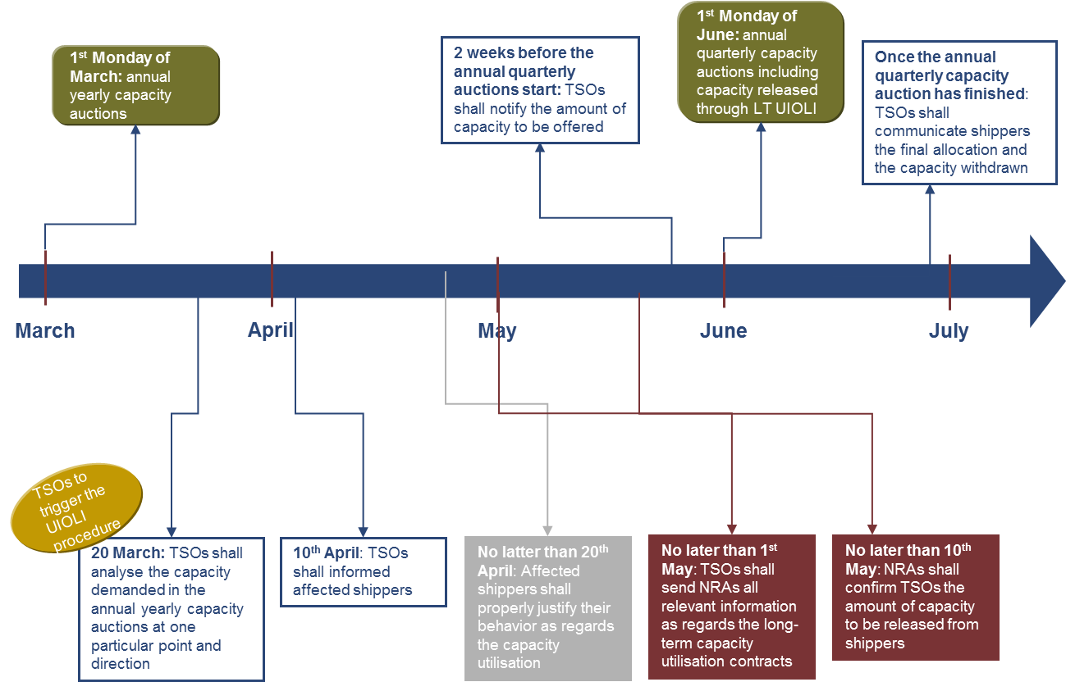

1. For the purpose of the application of the LT UIOLI procedure Y means a natural year (1 January to 31 December). However, noted that the gas year Y starts 1 October year Y and ends 30 September year Y+1
2. This classification will covered all capacity contracts with a duration of one year or more, both signed before and after the implementation of the Network Code on Capacity Allocation Mechanisms.